**Project Name : Apple TV+**

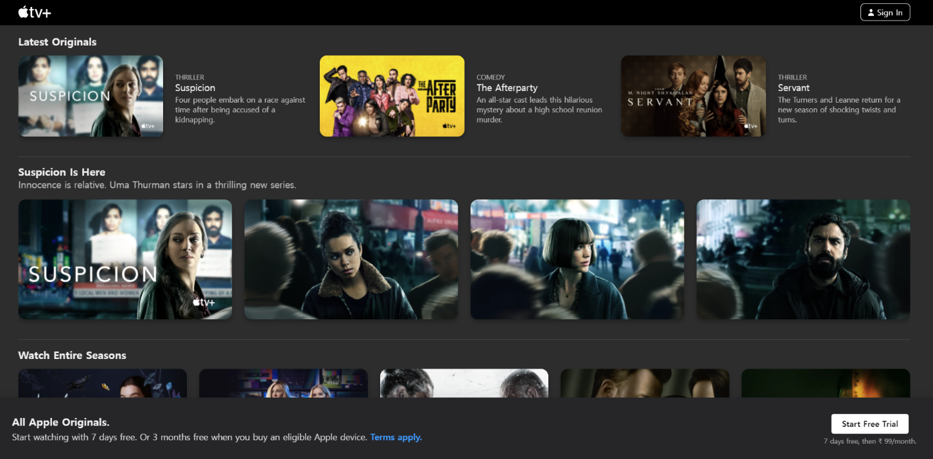

**\*OVERVIEW:** It’s an content streaming OTT website.

All the new series and exclusive ovies are

available under one roof to watch and enjoy.

1. **HOME PAGE:**

# LOGO

# ICONS - (SIGN IN)

# SEARCH BAR

# SLIDERS WITH ARROWS - (IMAGES)

# SHOWS- (IMAGES)

# NEW RELEASES - (IMAGES)

# TRENDING - (IMAGES)

# FOOTER – ( CONTACT US , HELPLINES , BRIEF DESCRIPTION

ABOUT THE COMPANY , SOCIAL-MEDIA HANDLE

ICONS )

1. **SIGN IN PAGE:**

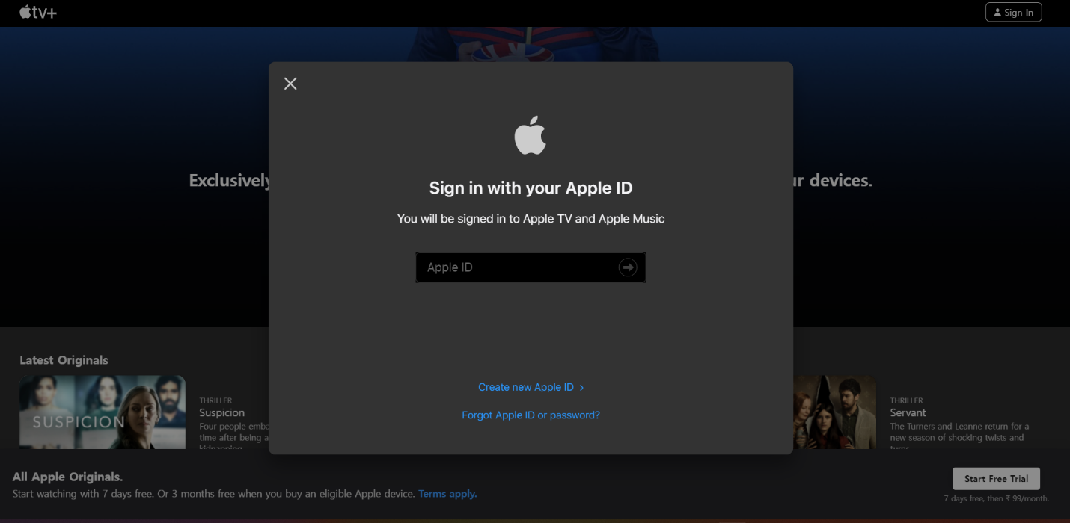

# APPLE ID

# E-MAIL ADDRESS

# PASSWORD

**3. MAIN PAGE:**

# LATEST ORIGINALS - ( ALL THE NEW ORIGINAL APPLE

CONTENT IS AVAILABLE TO WATCH)

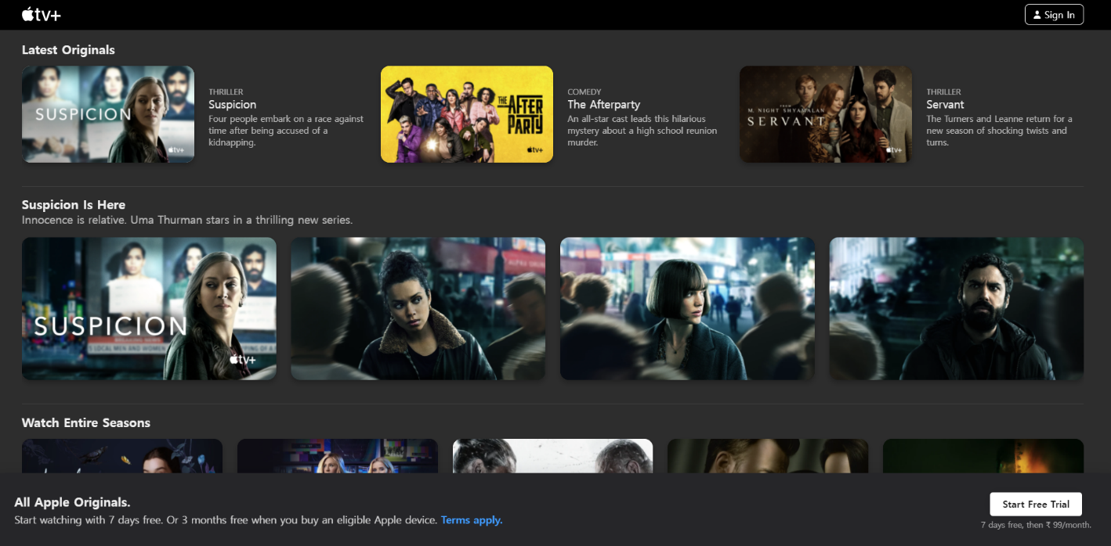

# TV SERIES - ( ALL THE NEW ORIGINAL APPLE

CONTENT IS AVAILABLE TO WATCH)

# ON CLICKING THE IMAGE - (MULTIPLE IMAGES OF THE

CONTENT WILL APPEAR FROM DIFFERENT SCENES )

1. **PAYMENT PAGE:**



# PAYMENT METHOD - ( BHIM UPI , CREDIT/DEBIT CARD , NET- BANKING )

**Presented By**

**Irfan Khan**